Estimation of Parameter:

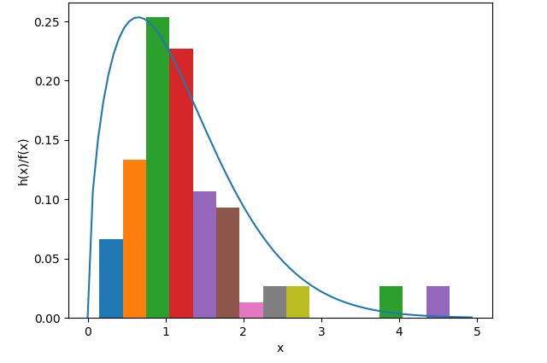

As our histogram resembles mostly with the density function of Weibull distribution, we will estimate parameters of Weibull(alpjha, beta), using Maximum-Likelihood Estimators(MLEs).

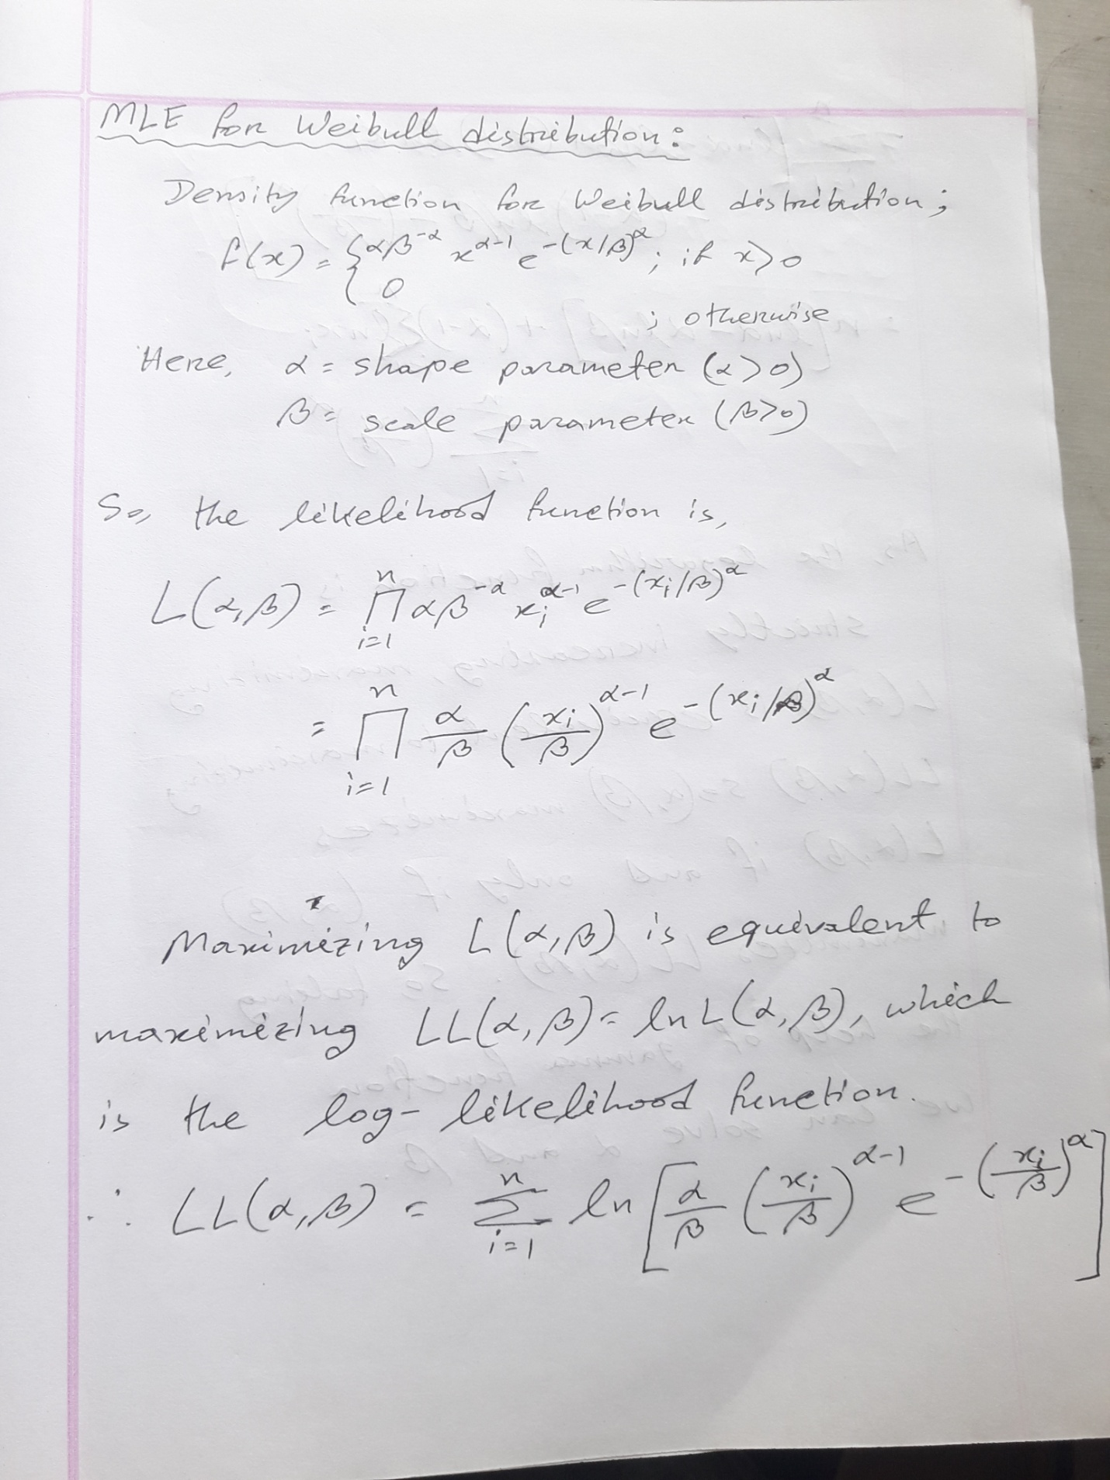

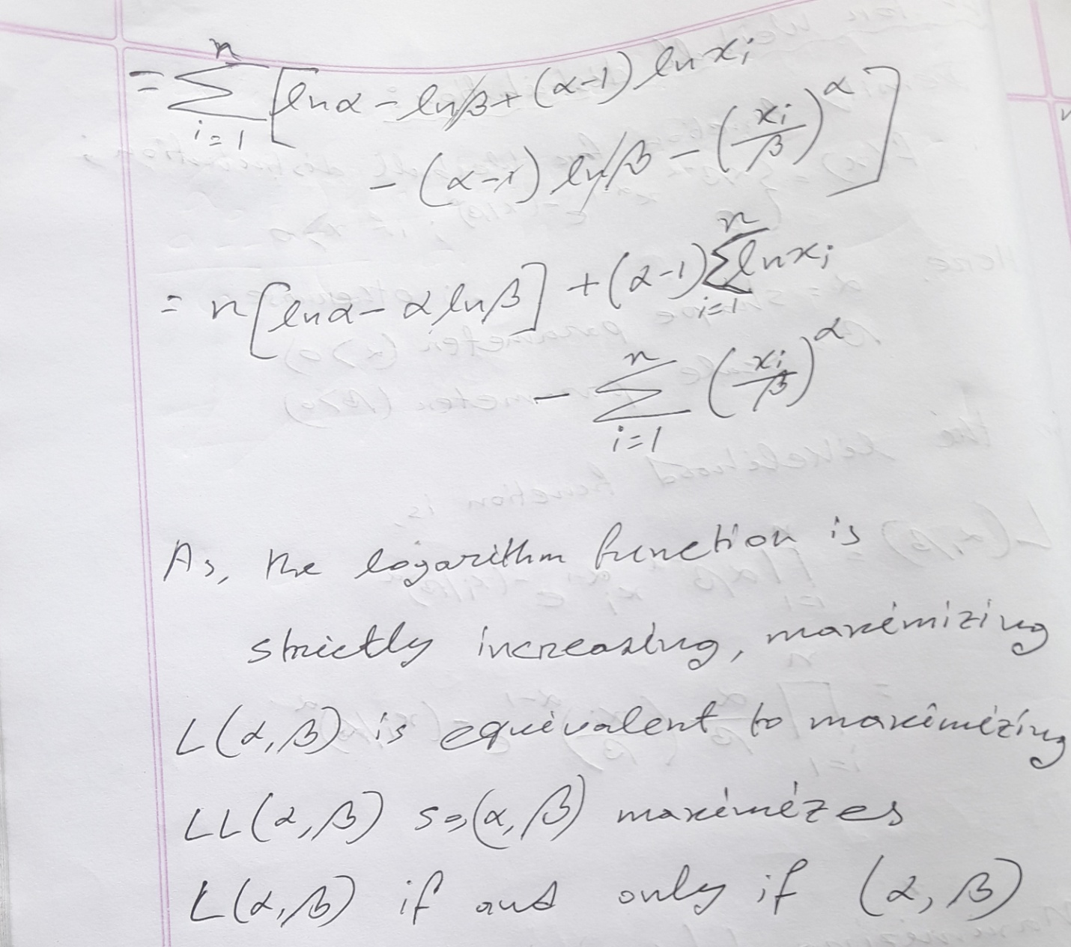

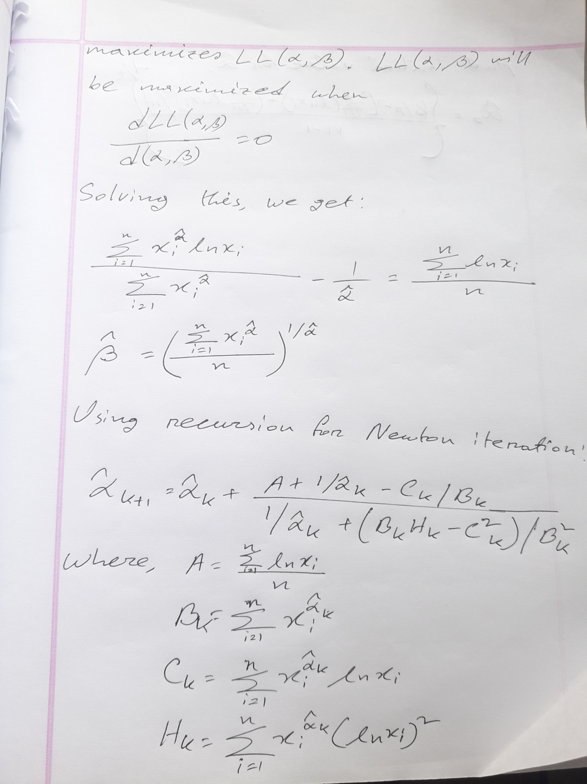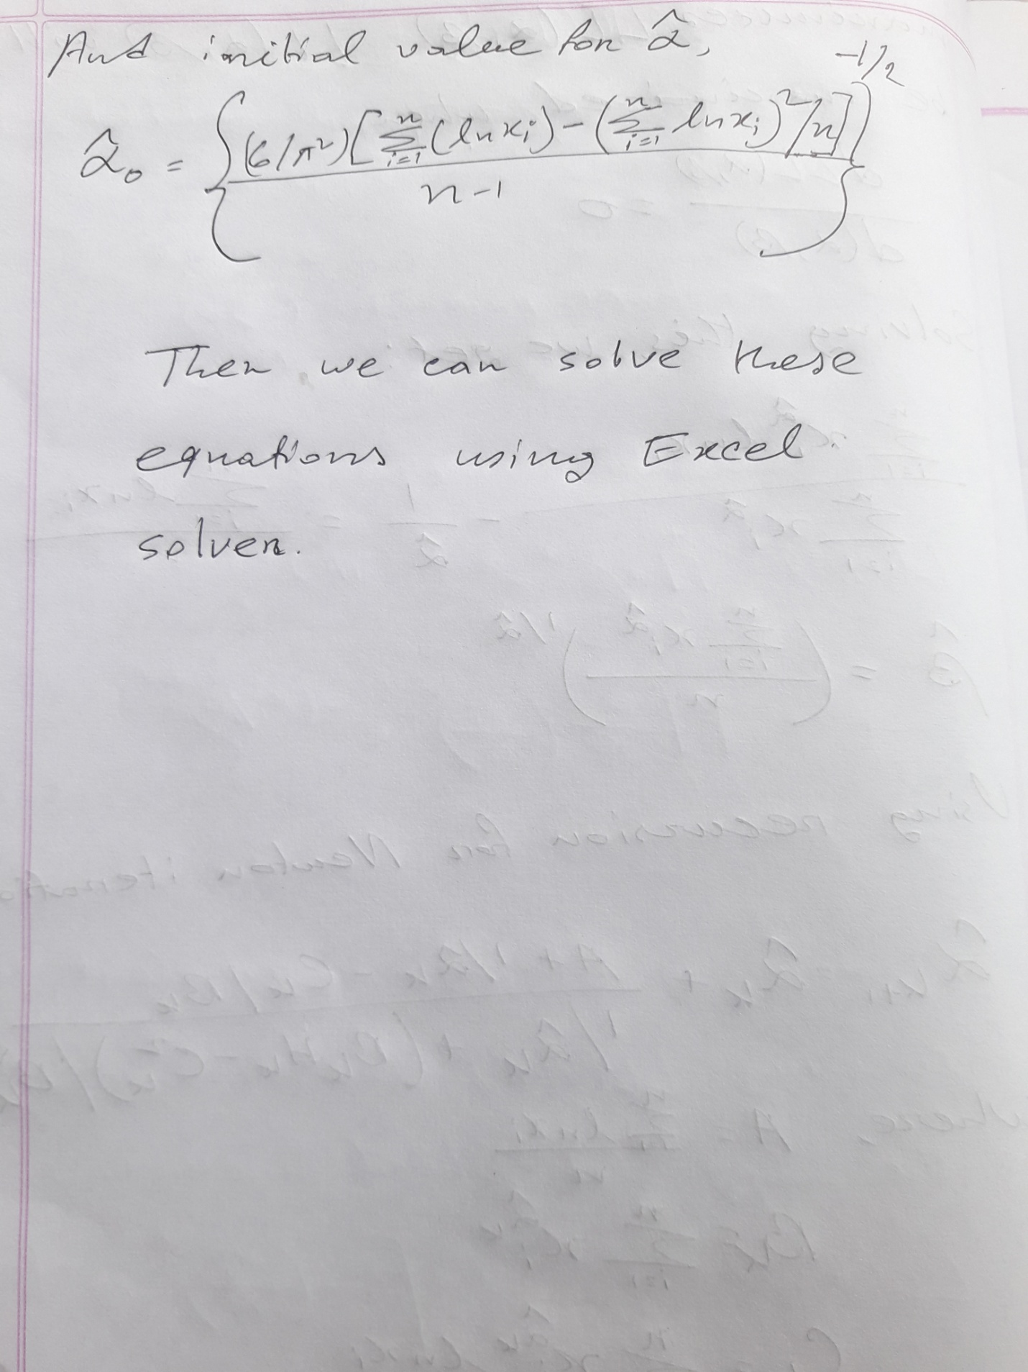**From this we estimate, Alpha= 1.5278996202501096, Beta= 1.2999425079066453**